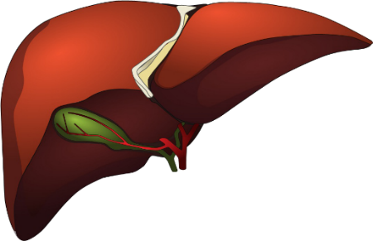 Scottish Liver Nurse Meeting
Friday 24th of March 2023
Radisson Blu – Glasgow

Thank you for registering to attend the Scottish liver nurse meeting.
Please could you complete the following and send back to Christine.McTaggart@ggc.scot.nhs.uk

Name
Hospital
Position
Email address
Dietary Requirements

We look forward to seeing you at the meeting.
Christine, Amanda, and Beth.

This event has been sponsored by Advanz pharma, Norgine,Pharmaceuticals Ltd. Dr Falk and Echosens. Sponsorship has been provided through event costs. The sponsors have had no influence on the content of this meeting or selection of speakers and will be in attendance on the day

