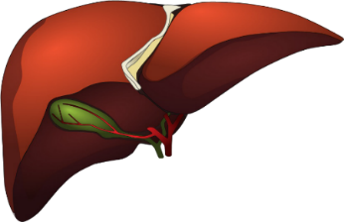
Scottish Liver Nurse Meeting
Friday 24th of March 2023
Radisson Blu – Glasgow
Registration 9:30-10:am
Session 1: Metabolic and alcohol related liver disease Chairperson Christine McTaggart (QEUH)
Time | Session | Speaker
10:00-10:05 | Introduction and House Keeping | Christine McTaggart
10:05-10:30 | We need to talk about NAFLD | Dr Rachael Swann, Consultant Hepatologist QEUH
10:30-11:00 | Dietetic input in decompensated liver disease. | QEUH dietetic team
11:00-11:30 | Alcohol related liver Disease | Prof Ewan Forrest, Consultant Hepatologist, Glasgow Royal Infirmary
11:30-11:45 | The future of the Scottish Liver Nurse Group | Christine McTaggart and Amanda Sharp
11:45-12:00 | SSG update | Kim MacBeth

12:00-1:00 Lunch
Session 2: Autoimmune Liver Disease Chairperson Amanda Sharp (Glasgow Royal)
1-1:30 | Autoimmune hepatitis in brief, with cases. | Dr Neil Lachlan, Consultant Hepatology, Glasgow Royal Infirmary
1:30-2:00 | PBC Audit | Dr Jo Leithead, Consultant Hepatologist, Forth Valley Hospital
2:00-2:30 | The 6C’s of PSC | Dr Jude Morris, Consultant Hepatologist, QEUH

2:30-2:45 – Coffee/ Teas
Session3: Palliation and End Stage Liver Disease Chairperson Beth Speirs (RAH)
2:45-3:15 | Time to get SCiLD | Dr Fiona Finlay, Consultant in Palliative Medicine, QEUH
3:15-3:45 | Hepatic encephalopathy management | Dr Michael Johnston, Consultant Hepatologist, QEUH
3:45-4 | Summary and Close | Chairs

If you would like to attend this meeting could you please email Christine McTaggart
Christine.McTaggart@ggc.scot.nhs.uk

